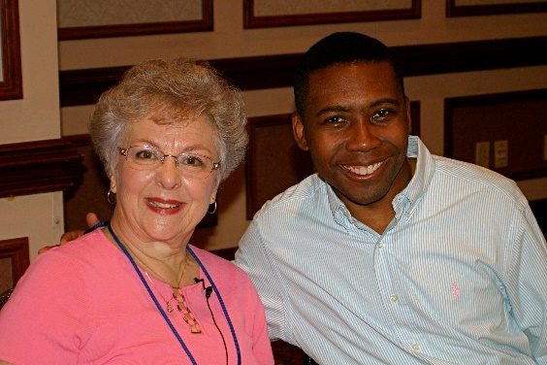
Dr. Rollo Dilworth
Professor of Choral Music Education
1715 N. Broad Street
Philadelphia, PA 19122

RE: Appalachian Festival of Young Voices

Dear Colleagues,
I hope your season of choral music is off to a wonderful start!
The purpose of this email is to invite you to consider being a part of the Appalachian Children's Choir Festival of Young Voices in June of 2022. I have been fortunate to serve as guest conductor for this festival since its inception in 2007. This festival, hosted by the Appalachian Children's Chorus and Founding Artistic Director Selina Midkiff, provides an exceptional musical and cultural experience for young singers. In addition to performing a quality and diverse repertoire (from classical to folk), singers are offered opportunities to learn about the rich cultural heritage of West Virginia and the Appalachian region. This is truly a unique festival experience for which I am proud to have an association!
For more information about the festival, please click here or email Selina Midkiff directly at selina@wvacc.org. I hope you will strongly consider this wonderful opportunity for your singers!
Best wishes,

Rollo Dilworth

